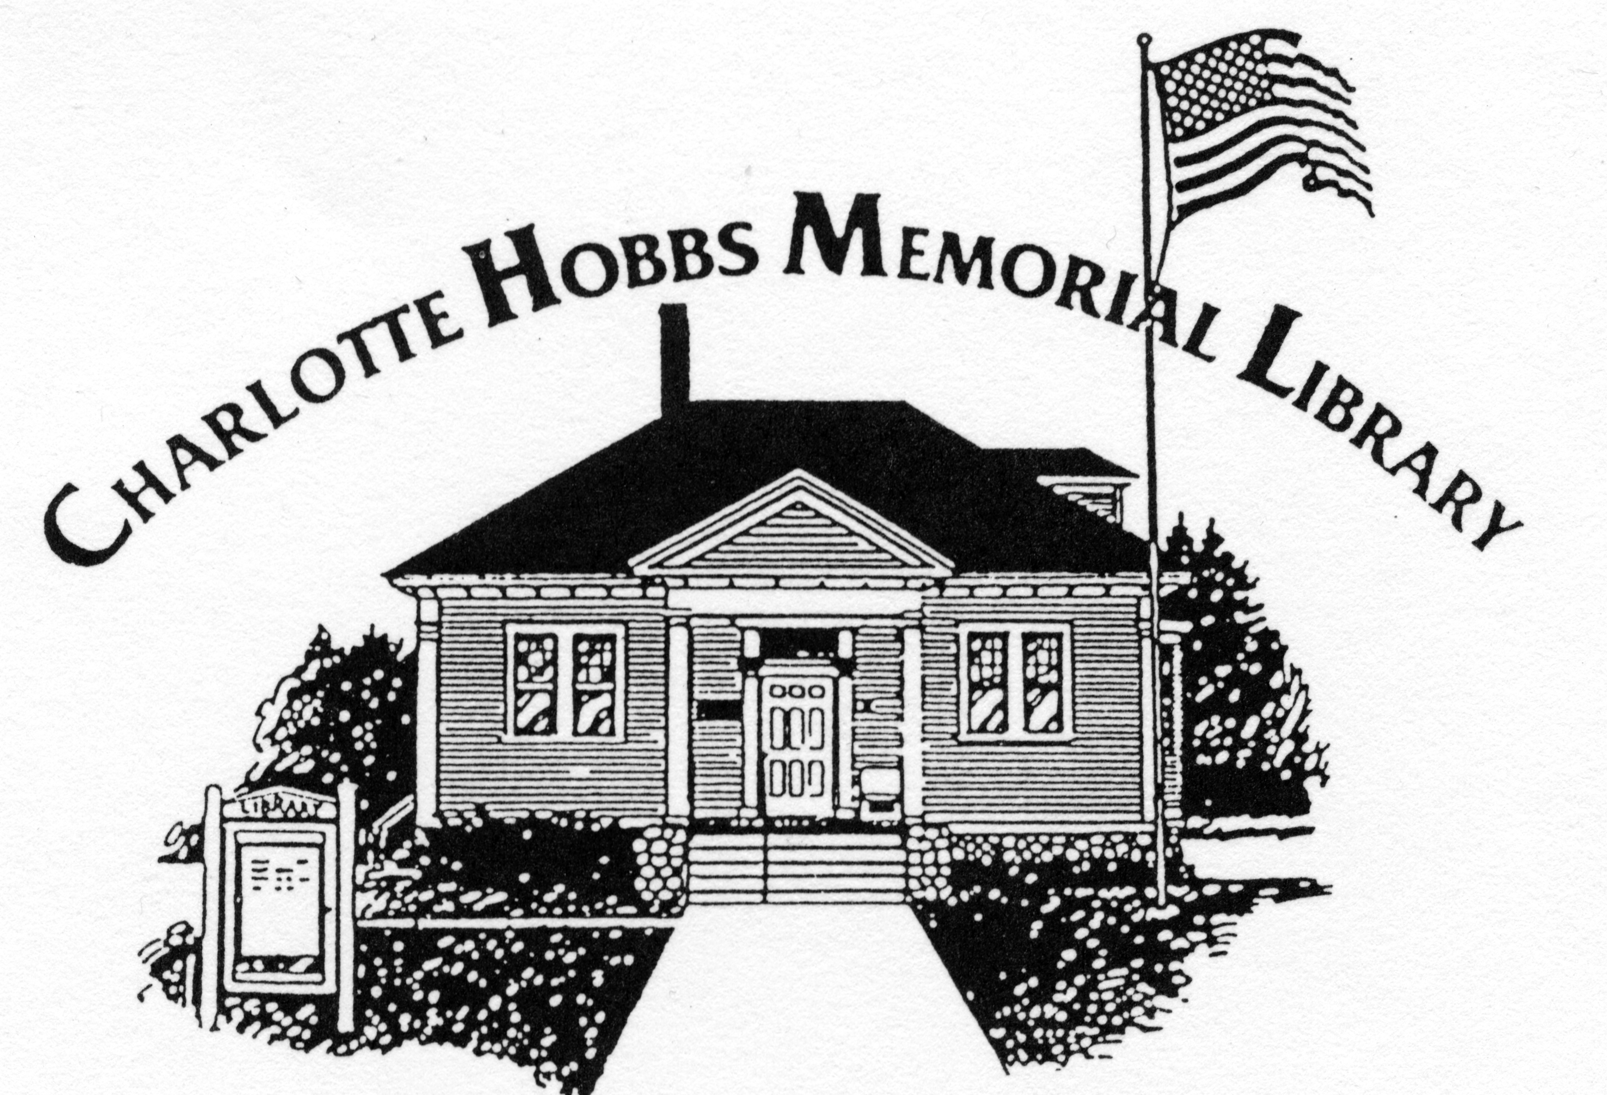
Charlotte Hobbs Memorial Library COMMUNITY YARD SALE
July 16, 2016 Vendor Application

On July 16, the day of Lovell Old Home Days, the library is inviting community members to join them on the front lawn of the library for a big yard sale. Please fill out this form if you would like us to reserve you a space so you can sell your own yard sale items.

Name:___________________________________________________________________________

Address:________________________________________________________________________

City:______________________________ State:___________ Zip:_______________________

Phone:_______________________________ Email:___________________________________

Space Rental: $15 (cash or checks payable to Charlotte Hobbs Memorial Library)
Space Size: 10 feet x 10 feet (you must provide your own tables, pop ups, etc.)
Space set-up: you may begin by 8 am and must be finished by 9 am
Space clean-up: not until after 1 pm but everything needs to be removed from library’s property by 2 pm.

I have read, understand, and agree to follow the guidelines above.

Signature: _______________________________

Date: _____________________ Please return application and check by July 11 to:
Charlotte Hobbs Memorial Library
PO Box 105
Lovell. ME 04051

QUESTIONS: call Lynn Hurd at 925-1101.

